STUDENT DATABASE MANAGEMENT
SYSTEM

Contents
Acknowledgements
Abstract

- Introduction Pg.No. 6
- Problem Statement Pg.No. 9
- Implementation details and code Pg.No. 10
- Screenshots Pg.No. 17

ABSTRACT

The main objective of college management system is to automate all functionalities of a college or university. Using this college management system you can view or update data and information about students and staffs easily. This system helps in managing the activity like student admission, student registration, student’s department. Admin can also retrieve information of staff and student. College Management System can store and manage all data of the various departments of a college like administration, searching student and staff details etc. Using this system user can retrieve any information related to student, staff. Using this system staff can check students record at anytime. College administration can also manage college work easily. We have written our code in C++ programming language; it doesn’t provide good interface but it works smoothly in command prompt with black interface. The benefits of college management system is that we can easily retrieve all information related to student and staff. Admin has all the collective records of students/staff of all the branches/department. This system gives easy approach to find the detailed information for any student/staff. Using this college management system it is very easy to handle all functionality of college. This system is beneficial for both students and staffs as they can get all previous or current information when they need. College management system can help to get all or a particular student information.

CHAPTER 1

INTRODUCTION

Database Management System is based on the concept to save and generate all the records of the user (especially student’s). This program is considered as a simple database of students and staffs in college, you can make it ordered by name or by name and usn, there are some functions help you to create a database. The user can save data in file after you finish their work, be attention the folder of the program must contain a file.The whole project is designed in ‘C++’ language and different variables and strings have been used for the development of this project. This project is easy to operate and understand by the users.
This mini project mainly focuses on adding and retrieving files. College Data Management system is developed using C++ Programming Language and different variables, strings have been used for the development of it. College Data Management System in C++ Programming is free to download with source code. Use for educational purposes only! This mini project provides the simplest system for managing students and teachers record in a college.
To read and write from a file. This requires another standard C++ library called fstream,
which defines three new data types –
Sr.No | Data Type & Description
1 | ofstream  This data type represents the output file stream and is used to create files and to write information to files.
2 | ifstream  This data type represents the input file stream and is used to read information from files.
3 | fstream  This data type represents the file stream generally, and has the capabilities of both ofstream and ifstream which means it can create files, write information to files, and read information from files.
To perform file processing in C++, header files <iostream> and <fstream> must be included in your C++ source file.

Using these above operations we will create a file of college database system management which will be secured by a password and it will contain the detail of students such as name, usn, department and staff details such as name, department, experience and these details will be displayed, to get the detail of any particular individual we can obtain by entering their name.

Objectives:
- The benefits of college management system is that we can easily retrieve all information related to student and staff.
- Admin has all the Collective records of students/staff of all the branches/department.
- This system gives easy approach to find the detail information for any student/staff.
- Using this college management system it is very easy to handle all functionality of college.
- This system is beneficial for both students and staffs as they can get all previous or current information when they need.
- College management system can help to get all or a particular student information.

This application provides information about student and staff of a college in which we can get number of students and staffs information stores in the database. We can get required student and staff’s data from this user friendly application. The right to modify any record is given to the admin. Development of this system will help the college to reduce unnecessary wastage of time.

CHAPTER 2

PROBLEM STATEMENT

Getting the details of student who are studying in college and staffs of the college and storing these details in file which will create a database of details of students and staffs and finally their details will be displayed by entering the name of particular student or staff.
Features:
1) Login.
2) Create student and staff database.
3) Insert student data and staff into the database etc..,

CHAPTER 3
IMPLEMENTATION

#include<iostream>
#include<fstream>
#include<string>
#include<iomanip>
using namespace std;
class student
{
public:
string fname, dept, lname, usn, sem;
} s[100];

class teacher
{
public:
string tname, tlname, sub, exper;
} t[100];

int main()
{
int login();
login();
int i=0,j;
string fnd,srch;
char choice;
while(1)
{
cout<<"\n\t\t\t1. Students Information"<<endl;
cout<<"\t\t\t2. Staffs Information"<<endl;
cout<<"\t\t\t3. Exit "<<endl;
cout<<"\n\t\t\tEnter your choice: ";
cin>>choice;
switch(choice)
{
case '1':
{
while(1)
{
char c2;
cout<<"\n\t\t\t---STUDENTS INFORMATION---\n\n\n";
cout<<"\t\t\t1. Create new entry\n";
cout<<"\t\t\t2. Find and display entry\n";
cout<<"\t\t\t3. Back to main\n";
cout<<"\n\n\t\t\tEnter your choice: ";
cin>>c2;
switch(c2)
{
case '1':
{
ofstream f1("student7.txt",ios::app);

for( i=0; c2!='n'&&c2!='N'; i++)
{
if((c2=='1')||(c2=='Y')||(c2=='y'))
{

cout<<"\n\t\t\tEnter First name: ";
cin>>s[i].fname;
cout<<"\t\t\tEnter Last name: ";
cin>>s[i].lname;
cout<<"\t\t\tEnter Usn: ";
cin>>s[i].usn;
cout<<"\t\t\tEnter the semester: ";
cin>>s[i].sem;
cout<<"\t\t\tEnter department name: ";
cin>>s[i].dept;
f1<<s[i].fname<<endl<<s[i].lname<<endl<<s[i].usn<<endl<<s[i].sem<<endl<<s[i].dept<<endl;
cout<<"\n\n\t\t\tDo you want to enter more students details? (Y/N)";
cin>>c2;
}
}
f1.close();
}
continue;

case '2':
{
ifstream f2("student7.txt");
cout<<"\n\t\t\tEnter student name to display student's record: ";
cin>>fnd;
int notFound = 0;
for( j=0; !f2.eof(); j++)
{
getline(f2,s[j].fname);
if(s[j].fname==fnd)
{
notFound = 1;
cout<<"\n\t\t\tFirst Name: "<<s[j].fname;
getline(f2,s[j].lname);
cout<<"\t\t\tLast Name: "<<s[j].lname;
getline(f2,s[j].usn);
cout<<"\t\t\tUSN: "<<s[j].usn;
getline(f2,s[j].sem);
cout<<"\t\t\tSemester: "<<s[j].sem;
getline(f2,s[j].dept);
cout<<"\t\t\tDepartment: "<<s[j].dept;
cout<<"\n";
}
}
if(notFound==0)
{
cout<<"\n\t\t\tNo data found"<<endl;
}
f2.close();
}
continue;
case '3':
{
break;
}
}
break;
}
continue;
}

case '2':
{
while(1)
{
cout<<"\n\t\t\t---STAFF INFORMATION---\n\n\n";
cout<<"\t\t\t1.Create new entry\n";
cout<<"\t\t\t2.Find staff and display\n";
cout<<"\t\t\t3.Back to main menu\n";
cout<<"\n\n\t\t\tEnter your choice: ";
cin>>choice;
switch(choice)
{
case '1':
{
ofstream t1("teacher7.txt",ios::app);

for(i=0; choice!='n'&&choice!='N'; i++)
{
if((choice=='1')||(choice=='Y')||(choice=='y'))
{

cout<<"\n\t\t\tEnter first name: ";
cin>>t[i].tname;
cout<<"\t\t\tEnter last name: ";
cin>>t[i].tlname;
cout<<"\t\t\tEnter subject name: ";
cin>>t[i].sub;
cout<<"\t\t\tEnter years of experiance: ";
cin>>t[i].exper;
t1<<t[i].tname<<endl<<t[i].tlname<<endl<<t[i].sub<<endl<<t[i].exper<<endl;
cout<<"\n\n\t\t\tDo you enter more staffs details? (Y/N)";
cin>>choice;
}
}
t1.close();
}
continue;
case '2':
{

ifstream t2("teacher7.txt");
cout<<"\n\t\t\tEnter staff name to be displayed";
cin>>fnd;
int notfound=0;
for( j=0; !t2.eof(); j++)
{
getline(t2,t[j].tname);
if(t[j].tname==fnd)
{
notfound=1;
cout<<"\n\t\t\tFirst name:"<<t[j].tname;
getline(t2,t[j].tlname);
cout<<"\t\t\tLast name:"<<t[j].tlname;
getline(t2,t[j].sub);
cout<<"\t\t\tSubject:"<<t[j].sub;
getline(t2,t[j].exper);
cout<<"\t\t\tYears of experience: "<<t[j].exper;
cout<<"\n";
}
}
t2.close();
if(notfound==0)
{
cout<<"\n\t\t\tNo data found";
}

}
continue;
case '3':
{
break;
}
break;
}
break;
}
continue;
}
default :
exit(0);
}
}
}

int login()
{
int id;
cout<<"\n\n\n\n\n\n\n\t\t\t COLLEGE DATA MANAGEMENT SYSTEM \n\n";
cout<<"\t\t\t------------------------------------\n\n";
cout<<"\n\t\t\t\t LOGIN \n";
here:
cout<<"\t\t\t\tEnter Password: ";
cin>>id;
cout<<"\n\t\t\t------------------------------------\n\n";
if(id==12345)
{
cout<<"\n\t\t\t\tAccess Granted... \n";
}
else
{
cout<<"\n\n\t\t\tAccess Not Granted!!! Please Try Again...\n\n";
goto here;
}
}

CHAPTER 4
SCREENSHOTS

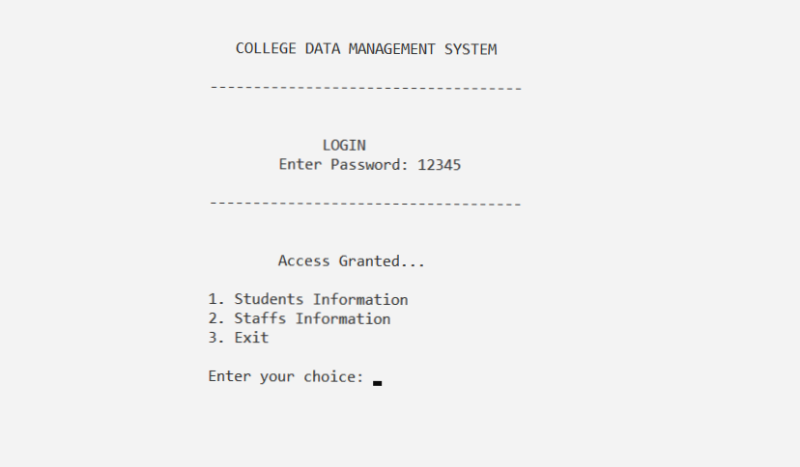

Figure 5.1: Login Screen of College database
Once we logged in with the provided password admin gets to choose 3 options 1) StudentInformation
2) Staffs Information and 3) Exit.

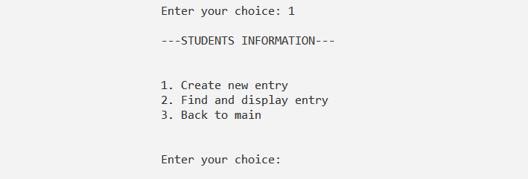

Figure 5.2: Students Information,
When we select the option 1 the admin gets control to update the student’s information section the
student,s information section has 3 fields 1) Creating a new entry 2) Searching for a student/s record and
3) Return to the main screen.

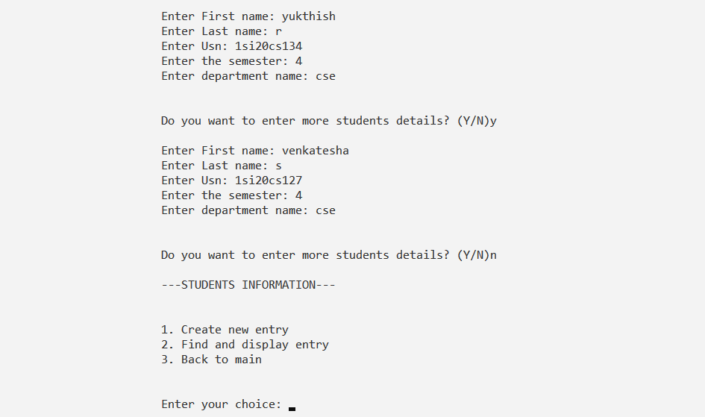

Figure 5.3: Creating a new entry
When we select the option 1 in student information field we can enter the details of a new student, once all the required fields are filled the control asks the user whether the admin want to continue the process or not(Y/N).

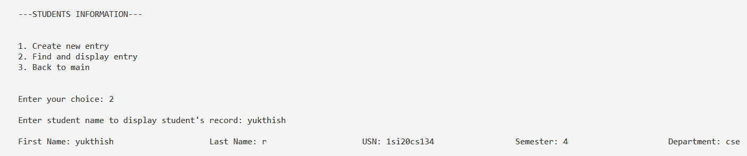
Figure 5.4: Find and display entry
The required student record is searched and displayed when the first name of the student is provided.

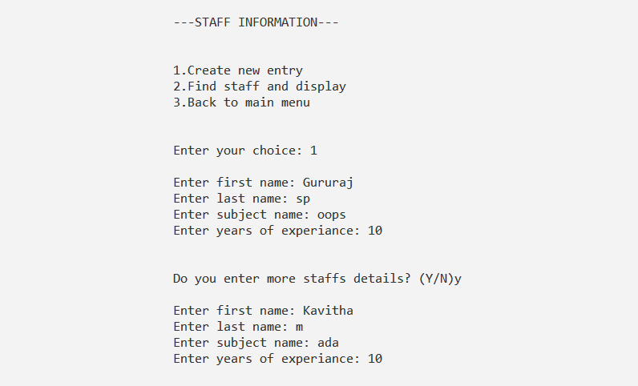

Figure 5.5: Staff Information In the main screen below the student section 2 option is for the staff’s record management. Once the admin enters the staff section there will be 3 choices 1) Create new entry 2) Search and display the staff and 3) Return to main screen. By selecting the choice 1 the required staff data is entered and it will be stored in the file.

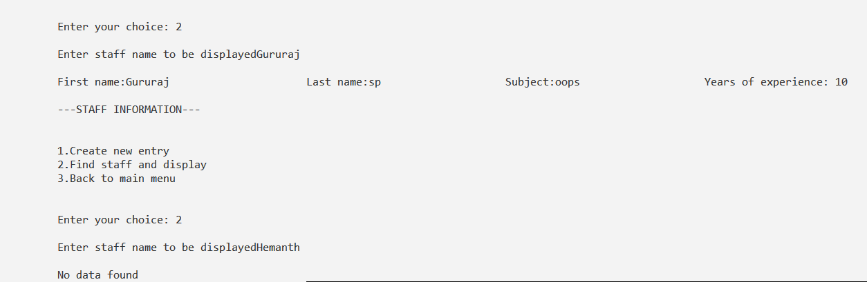

Figure 5.6: Find and display the staff
The required record of the staff is searched and displayed by entering his/her first name and if any another staff is searched who’s not in the database then the message of no data found is shown to admin.

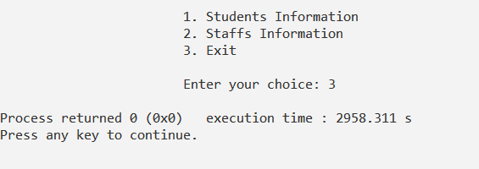
Figure 5.7: Exit
The required operations are done by the admin and in the main screen choice 3 is opted to exit from the database.

REFERENCES
    - Object Oriented Programming with C++, 6th Edition- E.Balagurusamy.

    - The Complete Reference C++ , -5th Edition – Herbert Schildt.

